Working on the Basic Linux commands execution in the terminal git bash
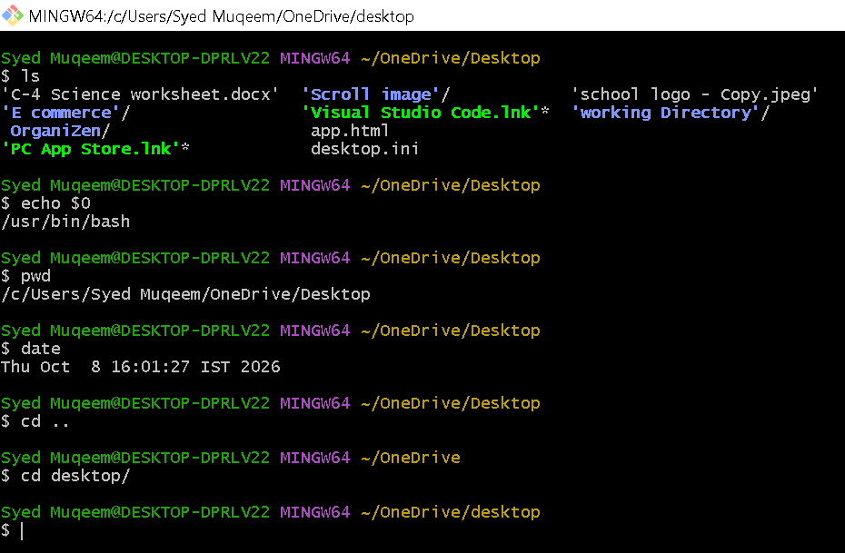

COMMANDS are used to:
- Ls (This command is used to display files and directories.)
- Echo $0 (This command used to find out which command shell you are currently running in your terminal.)
- Pwd "Print Working Directory". (Its only job is to show you the exact folder path you are currently standing in inside the terminal.)
- Date (This command is used to show the current date and time of your computer)
- Cd.. (This command is is used to taking you out of your current folder and into its "parent" folder.)

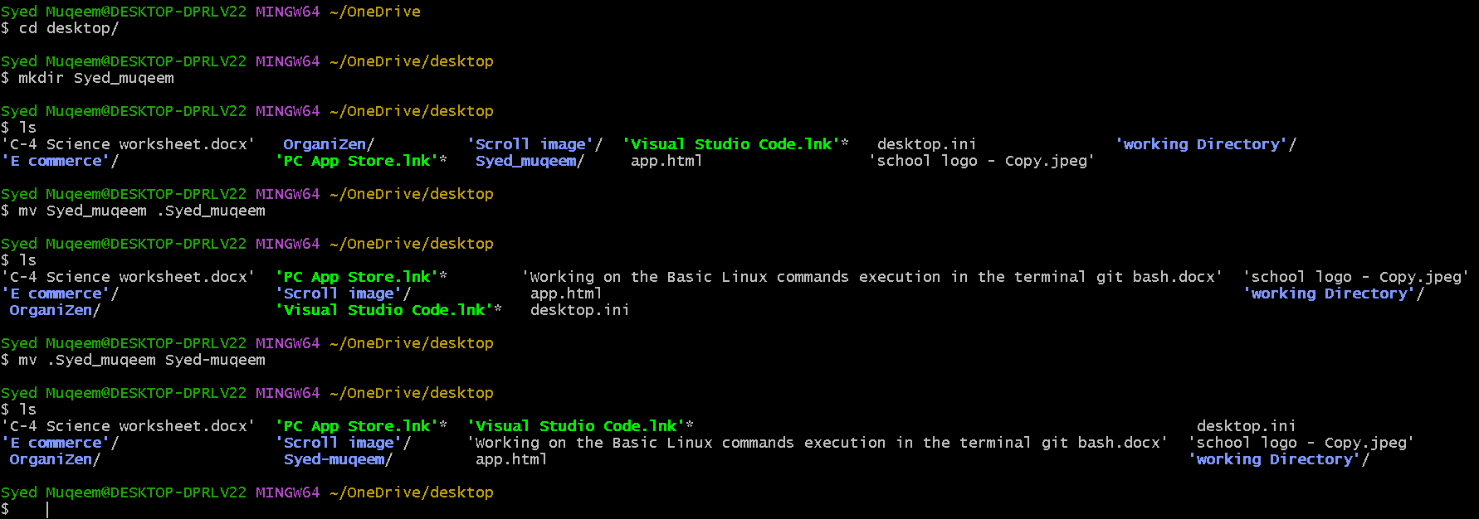

- cd desktop/ (This is used to move inside the folder named "desktop" from your current location.)
- mkdir (This command is used to create a new directory)
- mv (This command is used to hide the directory ex. Mv Syed_muqeem .Syed_muqeem)
- mv (This command is also used to rename the directory ex. .Syed_muqeem Syed-muqeem)
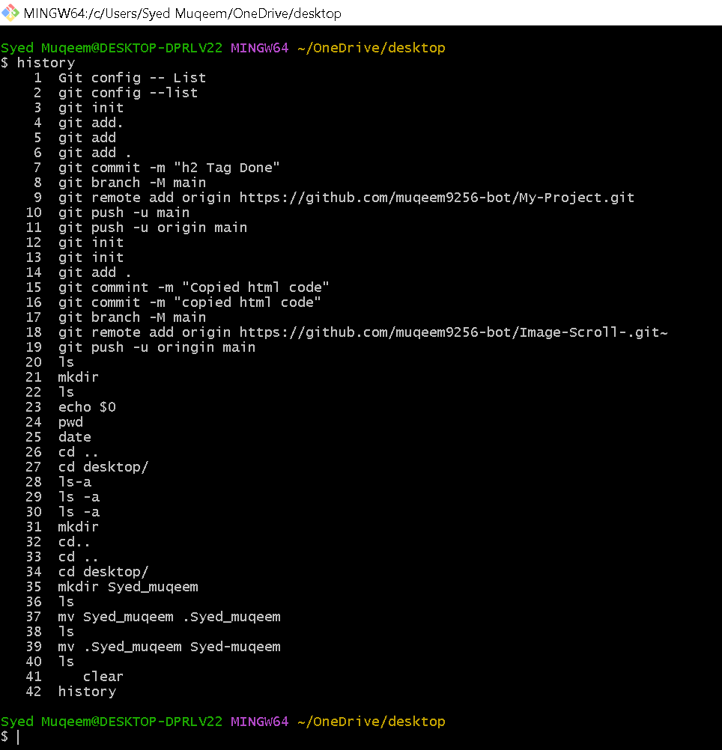

- clear (This command is used to clear the screen)
- History (This command is used to check the history of all the executed commands)

